传统socket

int socket(int domain, int type, int protocol);

domain：指定一个通信域

struct net_proto_family {//表示一个域

int family;

int (*create)(struct net *net, struct socket *sock,

int protocol, int kern);

struct module *owner;

};

例如：

static const struct net_proto_family inet_family_ops = {

.family = PF_INET,

.create = inet_create,

.owner = THIS_MODULE,

};

注册：sock_register(&inet_family_ops );

socket函数调用到内核的上面的inet_create

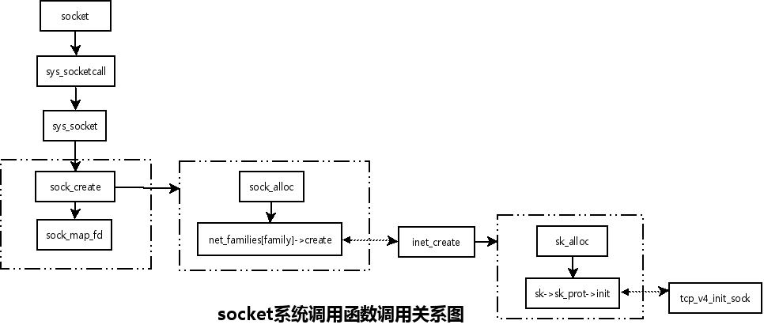

PF_PACKET：

static const struct net_proto_family packet_family_ops = {

.family = PF_PACKET,

.create = packet_create,

.owner = THIS_MODULE,

};

struct packet_type {//包接收类型:包含钩子函数 还有type：protocol类型(对应于socket第三个参数)

__be16 type; /* This is really htons(ether_type). */

struct net_device *dev; /* NULL is wildcarded here */

int (*func) (struct sk_buff *,

struct net_device *,

struct packet_type *,

struct net_device *);

struct sk_buff *(*gso_segment)(struct sk_buff *skb,

u32 features);

int (*gso_send_check)(struct sk_buff *skb);

struct sk_buff **(*gro_receive)(struct sk_buff **head,

struct sk_buff *skb);

int (*gro_complete)(struct sk_buff *skb);

void *af_packet_priv;

struct list_head list;

};

/*操作函数 包括bind connect sendmesg等等 如果是PF_INET 那么这个就根据protocol选择udp或者tcp的处理函数 如上图(在PF_INET协议上支持的套接字接口有流套接字(SOCK_STREAM)，数据报套接字(SOCK_DGRAM)和原始套接字(SOCK_RAW),结构为struct inet_protosw 的proto_ops)*/

struct proto_ops {

int family;

struct module *owner;

int (*release) (struct socket *sock);

int (*bind) (struct socket *sock,

struct sockaddr *myaddr,

int sockaddr_len);

int (*accept) (struct socket *sock,

struct socket *newsock, int flags);

int (*getname) (struct socket *sock,

struct sockaddr *addr,

int *sockaddr_len, int peer);

unsigned int (*poll) (struct file *file, struct socket *sock,

struct poll_table_struct *wait);

int (*ioctl) (struct socket *sock, unsigned int cmd,

unsigned long arg);

.....

}

static struct proto packet_proto = { //packet_proto->obj_size 决定了分配的大小 如果是PF_INET 那么这个就根据protocol选择udp或者tcp的 //proto(结构同上struct inet_protosw 的proto)

.name = "PACKET",

.owner = THIS_MODULE,

.obj_size = sizeof(struct packet_sock),

};

socket->sys__socket ->socket__creat->packet_family_ops->create;

static int packet_create(struct net *net, struct socket *sock, int protocol, int kern)

{

sk = sk_alloc(net, PF_PACKET, GFP_KERNEL, &packet_proto);//分配sk结构体 sk->sk_prot = packet_proto; packet_proto->obj_size 决定了分配的大小，struct packet_sock第一个成员就是sk，所以有(struct packet_sock*)sk就成了一个struct packet_sock

sock->ops = &packet_ops;//struct proto_ops packet_ops;//

packet_sock->prot_hook.func = packet_rcv;/*struct packet_type packet_sock->prot_hook;作为packet_sock的成员*/

packet_sock->prot_hook.type = protocol;

packet_sock->prot_hook.af_packet_priv = sk；//sk传给包类型，方便接收到包后找到相应的sock

dev_add_pack(&po->prot_hook);//把packet_type加入相应的type或者全局接收列表中

}

**应用层**的bind ioctl connenct sendmesg等都是调到内核的sock->ops(packet_ops)实现的。

bind——Sys_bind——packet_bind(sock->proto_ops->bind)

sendmsg——sys_sendmsg——packet_sendmsgsock->proto_ops->sendmsgt)

rcvmsg()——sys_sendmsg——packet_revmsg()(sock->proto_ops->revmsg)

........

**包的接收：**

网卡驱动--->netif_rx()--->netif_receive_skb()->deliver_skb()->packet_type.func->packet_rcv;

static int packet_rcv(struct sk_buff *skb, struct net_device *dev, struct packet_type *pt, struct net_device *orig_dev)

{

sk = pt->af_packet_priv;//获取sk

struct packet_sock *po = (struct packet_sock*)sk；//获取packet_sock

res = run_filter(skb, sk, snaplen);//根据过滤规则过滤

__skb_queue_tail(&sk->sk_receive_queue, skb);//包传到sk的queue上

}